Shabbos Stories for
Parshas mikeitz 5781
Volume 12, Issue 16 4 Tevet/December 19, 2020
Printed L’illuy nishmas Nechama bas R’ Noach, a”h

For a free subscription, please forward your request to keren18@juno.com
Past stories can be found on the website ShabbosStories.com

The Jew Who Loved the Mitzvah of Hahnasas Orchim

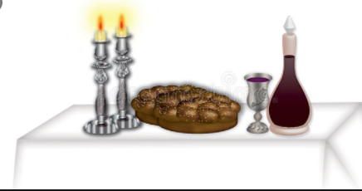

Reb Eliezer, the father of the great Baal Shem Tov, loved performing the Mitzvah of Hachnasas Orchim, welcoming guests. He used to send people out to look for anyone who needed a place to eat, so they could come to his house and have a warm meal.
Before sending guests on their way, he would give them a package of food so they wouldn’t get hungry on the road before they got to their destination, and he would also give them gifts, so they had everything they needed. Hashem saw how exceptionally Reb Eliezer did the Mitzvah, and decided to test him so he could earn a great reward.
The Satan jumped at the chance, and said, “I’ll go test him!”
But Eliyahu HaNavi said, “Perhaps it is better if I go.”

Hashem Allowed Eliyahu HaNavi to Test Reb Eliezer
Hashem allowed Eliyahu HaNavi to go test Reb Eliezer. It was Shabbos afternoon when Eliyahu HaNavi appeared at Reb Eliezer’s door. Eliyahu HaNavi was disguised as a very poor man. He was holding a walking stick and wearing a backpack, and he gave the impression that he was being Mechalel Shabbos, desecrating Shabbos, by carrying in a place without an Eiruv.
Eliyahu HaNavi knocked at the door, and after he was welcomed, said “Gut Shabbos,” and entered Reb Eliezer’s house. Reb Eliezer was very careful not to embarrass his guests, and always tried to make them comfortable. He controlled himself and didn’t say anything about his guest being Mechalel Shabbos.
Instead, he made a great effort to serve Shalosh Seudos with happiness, and after Shabbos, he served the Melaveh Malkah Seudah to his guest. Reb Eliezer wouldn’t hear of letting his guest leave at night, and insisted that he remain overnight. The next morning, Reb Eliezer gave the poor man a large package of food and a nice amount of Tzedakah, so he could buy himself some new clothes.

Didn’t Criticize the Man for Being
Mechales (Desecrater) of Shabbos
He didn’t say a word about how the man was Mechalel Shabbos, and wished him farewell. It was then that the man revealed to Reb Eliezer that he was really Eliyahu HaNavi!
“Hashem sent me to test you on the great Mitzvah of Hachnasas Orchim,” he said. “Because you passed the test so well, and didn’t embarrass me when I came to your door, Hashem will Bentch you with a very special child who will shine brightly in Klal Yisroel!”
Soon after, the benevolent Reb Eliezer had a child who grew up to be the famous Baal Shem Tov!

Reprinted from the Parashat Hukat Balak 5780 email of Rabbi David Bibi’s Shabbat Shalom from Cyberspace. The story originally appeared in that week’s Jersey Shore Torah Bulletin.

Stranger on a Train
By Readers' Digest

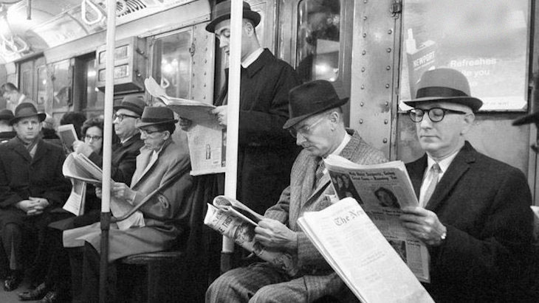
A serendipitous encounter with a Hungarian survivor leads to an incredible reunion.

Marcel Sternberger, a photographer, was a creature of habit. He used to take the 9:09 Long Island Railroad to Woodside every morning. But on the morning of January 10, 1948, he didn’t do it. He decided to go and visit a sickly friend who was dying. He wanted to pay him a visit because he knew he wouldn’t be around that much longer. As a result, Marcel hopped on a different train – a train that he had never ridden before.
As he got on another man got up hurriedly to leave. This left a vacant seat which Marcel managed to get. Sitting next to him was a man who was reading a Hungarian newspaper. Marcel Sternberger, being of Hungarian decent himself, eventually struck up a conversation with the fellow. He asked the stranger what he was doing in New York City. The man replied that he was in the city looking for his wife.
“What do you mean, you’re looking for your wife?”
The stranger then said, “Well, my wife and I used to live in Dubreken in Hungary. During the war, I was taken away and made to work in the Ukraine burying the German dead. In time I managed to escape and run back to freedom. When I returned home, I found that my wife had also been taken away by the Nazis. One of the neighbors said they thought she had been taken to Auschwitz and therefore she would have been killed in the gas ovens.”

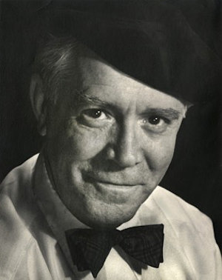
Marcel Sternberger

Someone else told him that they thought that the Americans had arrived in time to save some of the prisoners and had taken some of them to America. His wife might have been among those that were rescued. He said, “By a long shot, I’m hoping my wife is here.”

“What is Your Wife’s Name?”
Marcel Sternberger kept listening to this story. The more he listened, the more familiar the account sounded to him. He asked, “What is your wife’s name?”
The stranger said, “My wife’s name is Maria. My last name is Paskin. It’s Maria Paskin.”
Sternberger took out his wallet and found a dog-eared piece of paper. As he looked down he saw the name Maria Paskin with a telephone number. He had met the lady at a party some time back. She had shared with him the same story that he had just heard. For some reason, he made a note of her name and number.
Marcel then said, “Look, I want to do something for you now. What is your name?”
He said, “My name is Bela Paskin.”
“Bela, get off with me at the next station.”
As they got off of the train, Marcel went over to a phone and called the number on the dog-eared piece of paper. After many, many, rings a feeble voice answered the phone. Marcel asked if he was speaking to Maria Paskin and she said that he was. He then went on to say, “Maria, my name is Marcel Sternberger. We met some weeks ago.”
She said that remembered him. He said, “Can you tell me what your husband’s name is?”
Rather shocked, the lady answered, “My husband’s name is Bela Paskin.”
“Can you tell me a little more about him?”

The Two Stories were Identical
Again, the two stories were identical. Sternberger said, “Just a moment, I think you’re about to witness one of the greatest miracles you will ever see.” Then, as Marcel held on to the receiver, he called Bela Paskin into the booth and he said, “Would you please speak to this person?”
In about 10 seconds or so Bela’s expression changed. His look was beyond description. He then started to scream as the tears profusely poured down his creeks, “It’s Maria! It’s Maria! It’s Maria!”
Marcel Sternberger took him away from the telephone and hailed a taxi. He was going to go with his new friend to be a part of the moment when he decided that the occasion was too sacred for him to witness. So he put Bela Paskin into the cab, paid the taxi driver, told him where to take him, and sent him on to the reunion of his dreams.

Reprinted from the Parshat Toldot 5781 website of Aish.com This story originally appeared in Readers' Digest in 1948.

Famous Portrait Photographer

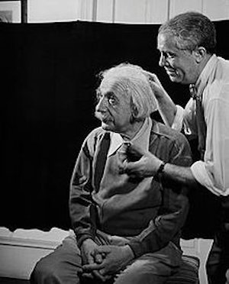
Marcel Sternberger photographing Albert Einstein, 1950

Marcel Sternberger (1899–1956) was a Hungarian-American [Jewish] photographer. He took portraits of many icons of his time including President Franklin Delano Roosevelt, Sigmund Freud, Frida Kahlo, Diego Rivera, Albert Einstein, H.G. Wells, George Bernard Shaw, Prime Ministers Jawaharlal Nehru and Indira Gandhi of India, and many others. His portrait of President Roosevelt became the image used as the model for the American dime. He served as "Private Photographer to the Belgian Royal Family" beginning in 1935 and his images of the royal children were printed on Belgian postage stamps, which bore his name.
Active from 1934 until his death in Christianburg, Virginia in 1956, his 22-year career spanned a tumultuous period in modern history. He began his life as a journalist, turning later to photography to capture events around him. While not a photojournalist in the traditional sense, his portraits of the world's political and cultural elite offered a glimpse into the personalities shaping events of the 20th century.
Over the course of his professional life, he developed a technique for using light, positioning, and a contemporaneous interview of his subjects to create not only a striking image of an individual, but one that allowed for personality, emotion, and experience to be visually expressed.^{[4]}

Reprinted from Wikipedia.

A Fascinating
Kiddush Hashem

Mr. Shlomo (Sol Werdiger) and Ambassador Oh Joon

Every once in a while, there is a story published about a Yid who truly lives up to the Torah’s mandate to be a light unto the nations. It has happened numerous times recently when a religious Jew showed what Jewish ethics is really all about. This story took place in 2016. Mr. Shlomo (Sol) Werdiger, CEO of Outerstuff, a company that produces sports apparel, received a phone call from Mr. Oh Joon, the South Korean U.N. Ambassador, asking to meet him for lunch at a Kosher restaurant in Manhattan.
Although Sol didn’t know the purpose of the meeting, he agreed to meet with Mr. Joon. At the meeting, Mr. Joon told him the following. “I have always heard negative stereotypes about Jews and Israel, and I took it at face value. Then, my daughter took an internship working on design in your company. Throughout the year, she has been telling me how wonderful it is to work at your business.” Mr. Joon spoke with equanimity and appreciation. Then, he continued, “I must tell you that there are four areas which stood out and impressed my daughter.

Four Points of Kiddush Hashem
1) Every day, at 1:30 p.m., no matter what was going on at the office, all the men including those from neighboring offices, retreated into a room to pray with sincerity and calm.
2) Every Friday, the office shut down early in the afternoon in preparation for your holy Sabbath and is closed on the Sabbath – this includes all workers no matter which faith or religion they maintain.
3) My daughter observed that each petitioner for charity – and there were many – was treated with respect and left with a check in hand.
4) My daughter was treated with the utmost respect and dignity.”
Because of the amazing experience and lessons the company taught his daughter, Mr. Joon took out his checkbook and was ready to write a check returning all his daughter’s earnings! He was wealthy and could afford it and he wished to impress upon Mr. Werdiger the extent of his gratitude and newfound appreciation for the Jewish people.
Sol Werdiger wouldn’t hear from it. “Thank you but I cannot accept your generosity. Your daughter worked hard and earned her salary and rightfully deserves her pay, and I will not accept any remuneration.”

The Following Payback
Then the ambassador relayed the following: “As you might know, I have voting privileges on behalf of my country, South Korea, at the United Nations. Because of my renewed appreciation of the Jewish people, I abstained from voting on resolutions against Israel on three occasions. In fact, at one resolution, I was the ninth vote needed to pass the motion and resolution against Israel and because I abstained, it didn’t pass!”
Sol Werdiger said that no one at the office had any idea that this girl was the daughter of an ambassador and no one ever imagined what type of impact their typical conduct at work had on her or how this impacted the votes against Israel. When R’ Shmuel Wosner zt”l counseled people about honesty in business, he would cite the Be’er HaGolah that says: “I write this for future generations: I saw many that became great and wealthy from the mistakes of non-Jews. In the end, they weren’t successful and lost their money and didn’t have blessing from it afterward ... And many have sanctified Hashem’s name and have returned funds where non-Jews erred in significant amounts. They prospered, became wealthy and were successful and left substantial amounts to their descendants.” (Heard from Mr. Sol Werdiger at a weekend retreat)

Reprinted from the Parshas Toldos 5781 email of Torah Tavlin.

The Benefits of a Catastrophe

Here is a story on this topic that I heard it from the baal maaseh: This person had the machlah (cancer), and his immune system was compromised due to the treatments. When the corona epidemic broke out (around Purim time), his doctor warned him to be cautious that he doesn’t catch the disease because his body is too weak to fight it off.
He was cautious – as much as possible. He kept away from people, he washed his hands often, and he wore a mask. Unfortunately, he still contracted the virus.
As the doctor predicted, it wasn't easy for his body to fight off the disease. He needed a respirator, and for a few days, his life was hanging on a thread. But, baruch Hashem, gradually, the virus left his body. Then the miracle occurred: The antibodies that fought off the virus also attacked the cancer. He was healed from both diseases!
This story is not meant to encourage those who are ill with cancer to try to catch the virus. That is something for doctors to determine – not us. We tell this story to bring across the point that when something negative happens, it is actually positive.
When the person in this story caught the virus, which he tried so hard to avoid, he and his family thought it was terrible. However, the problem ended up being the critical cure that he needed. Similarly, whenever we go through challenging moments in life, we must know that it is all for the good.

Reprinted from the Parshas Toldos 5781 email of Torah Wellsprings: The Collected Insights of Rabbi Eli Biderman.
The Unexpected
Covid 19 Bonus

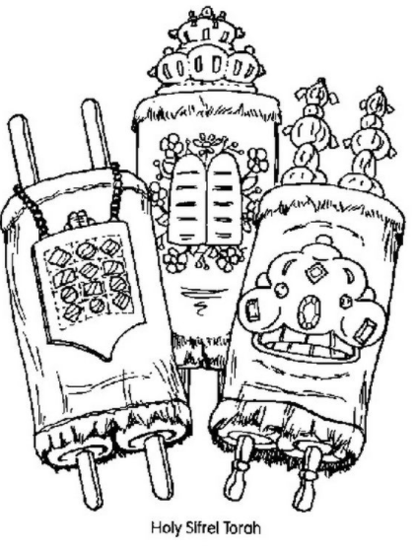

Here's another story; it happened to a yungerman who is in our chaburah: He published a sefer last year, which was sold primarily to menhalim, principals of chadarim, who distributed the sefarim among their students.
One organization wanted to make a large order and distribute the sefarim among their friends and supporters; however, the head of the organization said that he couldn't buy the sefarim without a receipt. It had to be sold legally.
The yungerman didn’t have any legal papers to offer, and he didn’t know how to obtain them. After some inquiries, effort, and not an insignificant sum of money, he made his small business official. He wrote receipts to this organization and to several principals who wanted to buy his sefer, and needed to prove that they made this purchase.
This happened last year, in Teves and Shevat. Soon afterward the Covid 19 pandemic hit, and the [Israeli] government was distributing monthly grants to small businesses to help them during this challenging time. This yungemran legally opened his business only two months before the virus outbreak, and he had several invoices. That was sufficient for him to be eligible for the monthly grant.
This yungerman was going through financial difficulties, and this monthly bonus helped him immensely. From this story, we learn two lessons: (1) Hashem gives parnassah, sometimes from the most unexpected places. (2) Although you might think something is negative, it is actually for your good. This yungerman considered it an unnecessary expense and hassle to arrange the legal papers, but it was for his benefit. It made him eligible for the grants.

Reprinted from the Parshas Toldos 5781 email of Torah Wellsprings: The Collected Insights of Rabbi Eli Biderman.

The Fortunate I.D.
Card Mistake

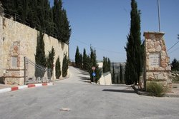
The Har HaMenuchos Cemetery in Jerusalem

An elderly American couple moved to Eretz Yisrael to live their final years in the holy land. A few years ago, the wife died and was buried on Har HaMenuchos. The widower moved to Kiryat Sefer to live near his children.
His ID card (teudat zehut) still said he lived in Yerushalayim. He tried to correct his ID to state his new residence but being an American and not well versed with Israeli bureaucracy, he didn’t succeed. Eventually, he made peace with the fact that his ID states that he lives in Yerushalayim.
When he was niftar, the family sent a copy of his ID papers to the chevrah kadishah of Har HaMenuchos, and the chevrah kadishah sold them a plot next to his deceased wife. He was interred there.
The family later discovered that they had experienced a miracle. Due to a shortage of available burial sites on Har HaMenuchos, the chevrah kadisha only allotted plots for residents of Yerushalayim. Had their father's ID stated that he lived in Kiryat Sefer, he wouldn’t have been buried next to his wife. This elderly person thought it was a problem when he couldn’t correct his ID papers.

Reprinted from the Parshas Toldos 5781 email of Torah Wellsprings: The Collected Insights of Rabbi Eli Biderman.

A Powerful Story
By Rabbi Moshe Meir Weiss

One of the methods by which we can smoothly absorb vital Torah teachings is through the vehicle of a story. I would like to share with you a well-documented vignette which carries some powerful and important lessons.
There was a chossid of the Maggid MiKozhnitz by the name of Reb Yosef. He and his wife were childless for many years. Often, he would ask the Maggid for a blessing but the Rebbe was not forthcoming. Finally, Reb Yosef’s wife, who was painfully pining for a child, forcefully told her husband that he should say to the Rebbe, “My wife told me not to leave the Rebbe’s presence until he blesses us with a child.”
Although uncomfortable, Reb Yosef acceded to the wishes of his suffering wife and told the Rebbe in her name that he wasn’t going to budge from the spot where he stood until he received a blessing.

Are You Ready to Become
Completely Impoverished?
The Rebbe stared at him and asked him, “Are you ready to become completely impoverished in order to have a child.” Reb Yosef was a responsible man and told the Rebbe that he couldn’t honestly answer the question unless he first asked his wife.
So, he went home and posed the question to his wife and she immediately responded, “What a question! What wouldn’t I do in order to coddle a child in my arms?”
Reb Yosef went back to the Rebbe and told him that they were ready to accept his demands. The Kozhnitzer Rebbe then told him, “Travel to the venerable Chozeh MiLublin and he will provide you with instructions.”
Dutifully, Reb Yosef journeyed to the Chozeh and told the famous Rabbi that he was sent by the Kozhnitzer to receive instructions on how to go about having a child.
The Chozeh gazed at him for a while and then informed him, “When you were a younger man, you were engaged to a girl and then broke off the engagement. You should know that your actions caused her tremendous pain. You never properly appeased her nor did you ask her for forgiveness. It is because of this that you are not able to have children… Travel now to the great market at Bolta. There you will find her and there you should ask for her forgiveness.”

Set Off to Bolta with No Idea of
How He Could Find the Woman
So, Reb Yosef set off to Bolta without having any idea how he was supposed to find a women he hadn’t seen in many years. Indeed, for several days he searched to no avail. One day there was a huge storm and he, together with others, ran for cover into a nearby store to get shelter from the rain.
As it was very crowded within this small enclosure, he was pushed very near to a woman. Being a religious chosid, he backed away from her whence she turned to him and said, “Many years ago you backed away from me and now you are doing the same thing!”
He looked at her and realized with amazement that this was the very woman he was searching for. Immediately, he revealed the purpose of his mission, apologized profusely and begged for her forgiveness.

A Condition for Which She Would Forgive Him
She responded that she had a very poor brother living in Slovakia who was having trouble marrying off his daughter because of lack of funds. She stipulated to him that if her were to go to her brother and give him 200 golden coins to help him marry off her niece, she would forgive him.
Reb Yosef calculated that if he liquidated all of his possessions he would amass the required 200 golden coins. He went home, procured the money and traveled on to Slovakia. There, he found her brother and indeed his daughter’s shidduch was about to unravel because he could not afford the wedding and the dowry.
Reb Yosef went over to him and gave him the 200 golden coins. The man looked at him incredulously and said, “I don’t even know you. Why are you doing this kindness?”
Reb Yosef revealed the whole story to him, and that his sister agreed to forgive him if he would help. The man looked at Reb Yosef as if he were a lunatic. “What are you talking about? My sister has been gone for 15 years. I buried her with my own hands. What games are you playing with me?”

A Well-Documented Story
Shocked and startled, Reb Yosef went on to describe exactly how she looked to the minutest detail and the brother paled saying that he was indeed precisely describing his sister. Reb Yosef went home and remarkably within the year, he and his wife were blessed with a healthy son! This is a well-documented story.
One of the places you can find it is in the Sefer Aperyon Shlomo.

Reprinted from the Parshat Toldot 5781 email of The Jewish Vues.

